Clean Code Principles - Keep Functions Small
# Source: AI Source: Provided by: [Data Path: Persons Table -> ID Column: 1, Name_En Column: Motasem Essam] -> From: [Chatgpt (GPT‑5 Mini)] on [12/9/2025]
Keeping functions small is a core principle of clean code. A function should do one thing only and do it well. Small functions are easier to read, test, maintain, and reuse.

🔑 Why Small Functions Matter
# Source: AI Source: Provided by: [Data Path: Persons Table -> ID Column: 1, Name_En Column: Motasem Essam] -> From: [Chatgpt (GPT‑5 Mini)] on [12/9/2025]
- Easier to understand at a glance
- Easier to test and debug
- Encourages reuse and modularity
- Reduces complexity and side effects

✅ Guidelines for Small Functions

1. Do One Thing Only
# Source: AI Source: Provided by: [Data Path: Persons Table -> ID Column: 1, Name_En Column: Motasem Essam] -> From: [Chatgpt (GPT‑5 Mini)] on [12/9/2025]
A function should have a single responsibility.
❌ Bad:
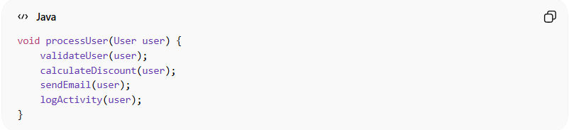
void processUser(User user) {
validateUser(user);
calculateDiscount(user);
sendEmail(user);
logActivity(user);
}
✔️ Good:
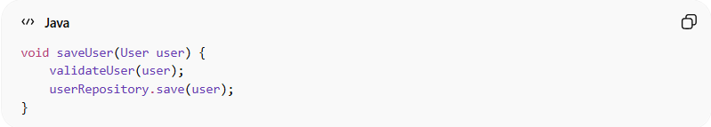
void saveUser(User user) {
validateUser(user);
userRepository.save(user);
}

2. Keep Function Length Short
# Source: AI Source: Provided by: [Data Path: Persons Table -> ID Column: 1, Name_En Column: Motasem Essam] -> From: [Chatgpt (GPT‑5 Mini)] on [12/9/2025]
- Prefer functions that are a few lines long
- If a function is long, it’s likely doing too much
❌ Bad:
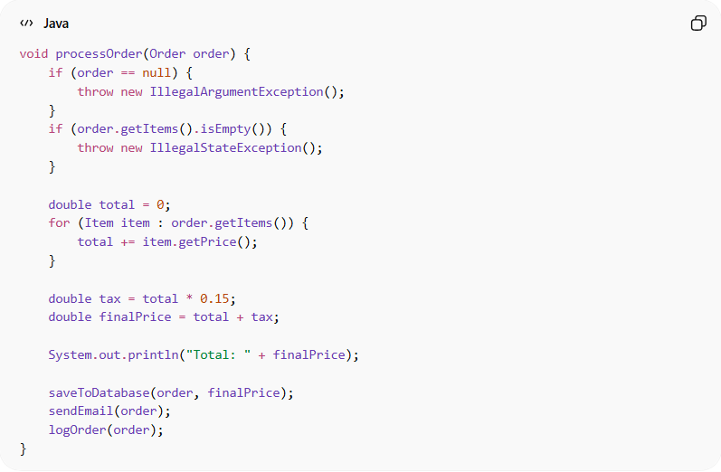
void processOrder(Order order) {
if (order == null) {
throw new IllegalArgumentException();
}
if (order.getItems().isEmpty()) {
throw new IllegalStateException();
}

double total = 0;
for (Item item : order.getItems()) {
total += item.getPrice();
}

double tax = total * 0.15;
double finalPrice = total + tax;

System.out.println("Total: " + finalPrice);

saveToDatabase(order, finalPrice);
sendEmail(order);
logOrder(order);
}
✔️ Good:
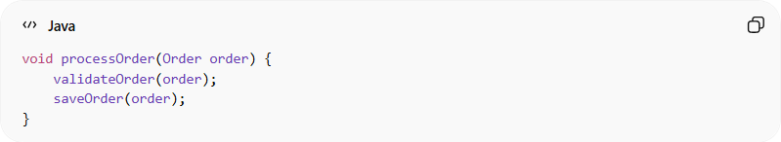
void processOrder(Order order) {
validateOrder(order);
saveOrder(order);
}

3. Extract Logic into Smaller Functions
# Source: AI Source: Provided by: [Data Path: Persons Table -> ID Column: 1, Name_En Column: Motasem Essam] -> From: [Chatgpt (GPT‑5 Mini)] on [12/9/2025]
Break large functions into smaller, meaningful ones.
❌ Bad:
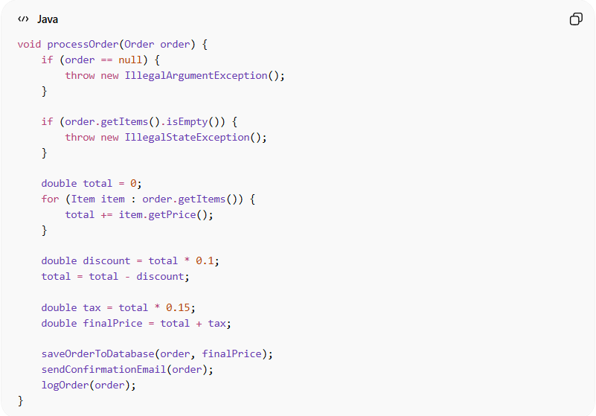
void processOrder(Order order) {
if (order == null) {
throw new IllegalArgumentException();
}
if (order.getItems().isEmpty()) {
throw new IllegalStateException();
}
double total = 0;
for (Item item : order.getItems()) {
total += item.getPrice();
}
double discount = total * 0.1;
total = total - discount;
double tax = total * 0.15;
double finalPrice = total + tax;
saveOrderToDatabase(order, finalPrice);
sendConfirmationEmail(order);
logOrder(order);
}

✔️ Good:
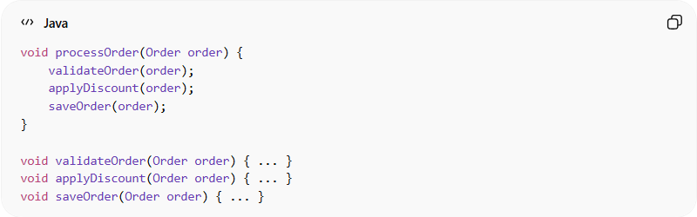
void processOrder(Order order) {
validateOrder(order);
applyDiscount(order);
saveOrder(order);
}
void validateOrder(Order order) { ... }
void applyDiscount(Order order) { ... }
void saveOrder(Order order) { ... }

4. Use Descriptive Function Names
# Source: AI Source: Provided by: [Data Path: Persons Table -> ID Column: 1, Name_En Column: Motasem Essam] -> From: [Chatgpt (GPT‑5 Mini)] on [12/9/2025]
If a function is small and well-named, it becomes self-explanatory.
❌ Bad:
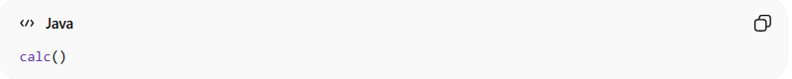
calc()
✔️ Good:
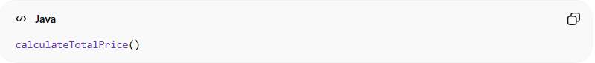
calculateTotalPrice()

5. Limit Parameters
# Source: AI Source: Provided by: [Data Path: Persons Table -> ID Column: 1, Name_En Column: Motasem Essam] -> From: [Chatgpt (GPT‑5 Mini)] on [12/9/2025]
Too many parameters make functions hard to read and use.
❌ Bad:
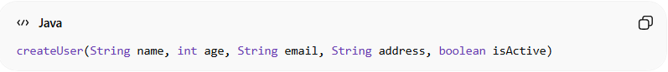
createUser(String name, int age, String email, String address, boolean isActive)
✔️ Good:
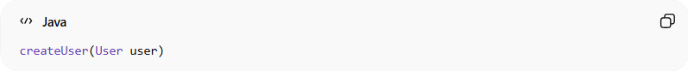
createUser(User user)

6. Avoid Side Effects
# Source: AI Source: Provided by: [Data Path: Persons Table -> ID Column: 1, Name_En Column: Motasem Essam] -> From: [Chatgpt (GPT‑5 Mini)] on [12/9/2025]
Small functions should do only what they promise.
❌ Bad:
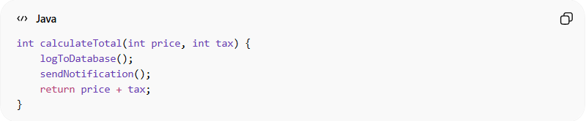
int calculateTotal(int price, int tax) {
logToDatabase();
sendNotification();
return price + tax;
}
✔️ Good:
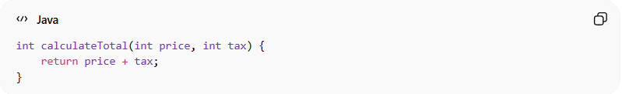
int calculateTotal(int price, int tax) {
return price + tax;
}

7. Avoid Deep Nesting
# Source: AI Source: Provided by: [Data Path: Persons Table -> ID Column: 1, Name_En Column: Motasem Essam] -> From: [Chatgpt (GPT‑5 Mini)] on [12/9/2025]
Deeply nested code increases complexity.
❌ Bad:
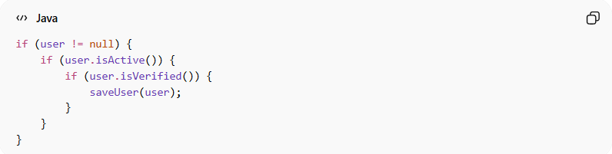
if (user != null) {
if (user.isActive()) {
if (user.isVerified()) {
saveUser(user);
}
}
✔️ Good:
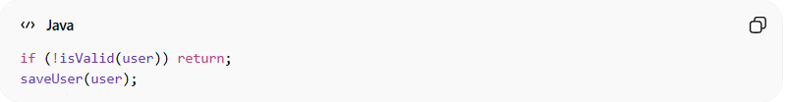
if (!isValid(user)) return;
saveUser(user);

🚫 Common Mistakes
# Source: AI Source: Provided by: [Data Path: Persons Table -> ID Column: 1, Name_En Column: Motasem Essam] -> From: [Chatgpt (GPT‑5 Mini)] on [12/9/2025]
- Functions doing multiple unrelated tasks
- Long, complex functions with many responsibilities
- Mixing logic, validation, and side effects in one function
- Overusing nested conditions

💡 Rule of Thumb
# Source: AI Source: Provided by: [Data Path: Persons Table -> ID Column: 1, Name_En Column: Motasem Essam] -> From: [Chatgpt (GPT‑5 Mini)] on [12/9/2025]
A function should fit on a single screen and be easy to understand without scrolling.

🧾 Summary
# Source: AI Source: Provided by: [Data Path: Persons Table -> ID Column: 1, Name_En Column: Motasem Essam] -> From: [Chatgpt (GPT‑5 Mini)] on [12/9/2025]
Small functions help you:
- Write cleaner and more readable code
- Follow the Single Responsibility Principle
- Reduce bugs and improve testability
- Build modular and maintainable systems

